Opti O2, LLC

MUTUAL NONDISCLOSURE AGREEMENT
This Mutual Nondisclosure Agreement (the “Agreement”) is made and entered into as of date (the “Effective Date”) by and between Opti O2, LLC, a Michigan limited liability corporation, and person name, a natural person.
- Purpose. The parties wish to explore a business opportunity of mutual interest, and in connection with this opportunity, each party may disclose to the other certain confidential technical and business information that the disclosing party desires the receiving party to treat as confidential.
- "Confidential Information" means any information disclosed by either party to the other party, either directly or indirectly, in writing, orally or by inspection of tangible objects (including, without limitation, any documents, prototypes, samples, plant and equipment).Confidential Information also includes, without limitation, any business plans, product ideas, marketing concepts, customer information, financial information and projections, which are designated as "Confidential," "Proprietary" or some similar designation, or which are of a nature which would commonly be considered proprietary to a party. Confidential Information may also include information disclosed to a disclosing party by third parties. Confidential Information shall not, however, include any information that (i) was publicly known and made generally available in the public domain prior to the time of disclosure by the disclosing party; (ii) becomes publicly known and made generally available after disclosure by the disclosing party to the receiving party through no action or inaction of the receiving party; (iii) is already in the possession of the receiving party at the time of disclosure by the disclosing party as shown by the receiving party's files and records immediately prior to the time of disclosure; (iv) is obtained by the receiving party from a third party without a breach of such third party's obligations of confidentiality; (v) is independently developed by the receiving party without use of or reference to the disclosing party's Confidential Information, as shown by documents and other competent evidence in the receiving party's possession; or (vi) is required by law to be disclosed by the receiving party, provided that the receiving party gives the disclosing party prompt written notice of such requirement prior to such disclosure and assistance in obtaining an order protecting the information from public disclosure.
- Non-use and Non-disclosure. Each party agrees not to use any Confidential Information of the other party for any purpose except to evaluate and engage in discussions concerning a potential business relationship between the parties. Each party agrees not to disclose any Confidential Information of the other party to third parties or to such party's employees, except to those employees of the receiving party who are required to have the information in order to evaluate or engage in discussions concerning the contemplated business relationship. Each party agrees that a breach by any of its employees shall be deemed to be a breach by such party of its obligations hereunder. Neither party shall reverse engineer, disassemble or decompile any prototypes, software or other tangible objects that embody the other party's Confidential Information and that are provided to the receiving party hereunder.
- Maintenance of Confidentiality. Each party agrees that it shall take reasonable measures to protect the secrecy of and avoid disclosure and unauthorized use of the Confidential Information of the other party. Without limiting the foregoing, each party shall take at least those measures that it takes to protect its own most highly confidential information and shall ensure that its employees who have access to Confidential Information of the other party have signed a non-use and non-disclosure agreement in content similar to the provisions hereof, prior to any disclosure of Confidential Information to such employees. Neither party shall make any copies of the Confidential Information of the other party unless the same are previously approved in writing by the other party. Each party shall reproduce the other party's proprietary rights notices on any such approved copies, in the same manner in which such notices were set forth in or on the original.
- Non Analysis. The receiving party agrees not to analyze chemically or otherwise any samples deemed confidential as per this agreement. However, it is understood that the receiving party may have to conduct certain physical testing in order to determine the suitability of the samples for use as component(s) of a sensing system. Supplying party permits receiving party to conduct such testing provided that such testing be limited to what is reasonably necessary for the stated purpose and that the results of such testing will be held in confidence.
- No Obligation. Nothing herein shall obligate either party to proceed with any transaction between them, and each party reserves the right, in its sole discretion, to terminate the discussions contemplated by this Agreement concerning the business opportunity.
- No Warranty. ALL CONFIDENTIAL INFORMATION IS PROVIDED "AS IS".EACH PARTY MAKES NO WARRANTIES, EXPRESS, IMPLIED OR OTHERWISE, REGARDING ITS ACCURACY, COMPLETENESS OR PERFORMANCE.
- Return of Materials. All documents and other tangible objects containing or representing Confidential Information that have been disclosed by either party to the other party, and all copies thereof that are in the possession of the other party, shall be and shall remain the property of the disclosing party and shall be promptly returned to the disclosing party upon the disclosing party's written request. However, subject to confidentiality and nonuse provisions of this Agreement, the receiving party may retain electronic information in archive storage or in such form as presently residing, so long as the same is inaccessible to anyone other than information technology personnel, to be destroyed or erased in accordance with the receiving party’s records management program.
- No License. Nothing in this Agreement is intended to grant any rights to either party under any patent, mask work right or copyright of the other party, nor shall this Agreement grant any party any rights in or to the Confidential Information of the other party except as expressly set forth herein.
- Term. The foregoing commitments of either party in this Agreement shall survive any termination of this agreement and shall continue for a period of five (5) years following the disclosure of each item of Confidential Information.
- Remedies. Each party agrees that any violation or threatened violation of this Agreement may cause irreparable injury to the other party, entitling the other party to seek injunctive relief in addition to all legal remedies.
- Miscellaneous. This Agreement shall bind and inure to the benefit of the parties hereto and their successors and assigns. This Agreement shall be governed by the laws of the State of Michigan without reference to conflict of laws principles. This document contains the entire agreement between the parties with respect to the subject matter hereof .Any failure to enforce any provision of this Agreement shall not constitute a waiver thereof or of any other provision hereof. This Agreement may not be amended, nor any obligation waived, except by a writing signed by both parties hereto.
- Severability. In the event any term of this Agreement is found by any court to be void or otherwise unenforceable, the remainder of this Agreement shall remain valid and enforceable as though such term were absent upon the date of its execution.
 | Opti O2, LLC |  |  | person-name
By: |  |  | By: | 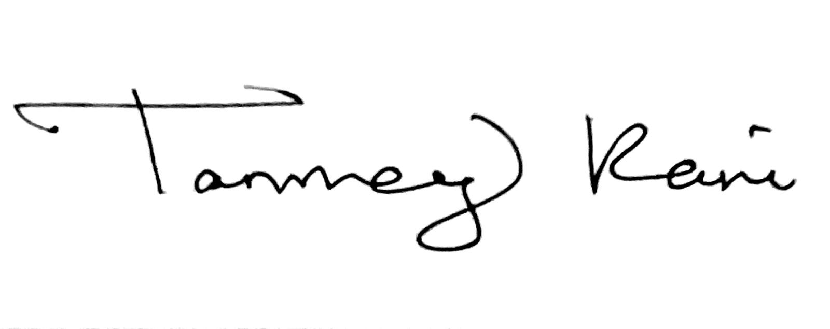
Name: | Ruby N. Ghosh |  | Name: | Tanmay Pani
Title: | President and CSO |  | Title:
Date: |  |  | Date: | 06/05/2026

